**Dhaka University of Engineering & Technology, Gazipur**



**DEPARTMENT OF COMPUTER SCIENCE AND ENGINEERING**

A REPORT ON

**DUET Medical Center Management System**

**Course Tittle: Software Engineering Sessional**

**Course Code: 4722**

**BY**

**Jahed Hasan ID:204003**

**Md. Sabbir Hossain Sojib ID: 204057**

**Md. Ayatullah ID:204059**

**Supervised By**

**Dr. Momotaz Begum**

PROFESSOR

Department of CSE, DUET

**Mr. Litan Islam**

LECTURER

Department of CSE, DUET

**ABSTRACT**

Nowadays, an online medical center management system is one of the most essential tools used in institutional healthcare services; it is primarily used to manage all medical and administrative activities. In this project, we have developed a computerized and web-based **DUET Medical Center Management System**. Our main goal is to enable this application to be used efficiently in the DUET medical center, with flexibility for minor customization based on institutional needs. This system is designed to overcome the limitations and challenges of the traditional manual management process previously followed. The system acts as an online medical center manager that streamlines various healthcare operations. By using this system, all daily medical transactions and services can be recorded, including patient registrations, employee records, medicine inventory, and appointment scheduling. It manages the entire workflow of the DUET Medical Centre, helping to improve service delivery, increase operational efficiency, and reduce the risk of data loss by securely storing all records in the system

**Keywords:** HTML, CSS, PHP, SQL, etc.

**ACKNOWLEDGEMENT**

We are truly grateful to the Almighty for giving us the strength and patience to complete this project successfully.

At the very beginning, we would like to sincerely thank our respected project supervisors, Pof. Dr. Momotaz Begum and Mr. Litan Islam, for their valuable guidance, helpful advice, and continuous support throughout the entire journey.

**TABLE OF CONTENTS**

**CONTENTS PAGE**

Abstract 2

Acknowledgements 2

**CHAPTER**

**CHAPTER 1: INTRODUCTION 4**

**CHAPTER 2: FEATURE (4-5)**

2.1 Admin 4

2.2 Employee 5

2.3 User 5

**CHAPTER 3: REQUIREMENT SPECIFICATION 6**

3.1 Hardware Configuration  **6**

3.2 Software Requirement 6

**CHAPTER 4: FLOWCHART,USE CASE & UML (7-11)**

4.1 Flowchart 7

4.2 Use Case Diagrams 7

4.3 UML Class Diagram 11

**CHAPTER 5: GRAPHICAL USER INTERFACE (12-15)**

**CHAPTER 6: TESTING 16**

**CHAPTER 7: CONCLUSION AND FUTURE SCOPE (17-18)**

7.1 Conclusion 17

7.2 Scope for Further Developments 17

7.3 Limitation 18

**REFERENCES** 18

**CHAPTER 1**

**INTRODUCTION**

The DUET Medical Center Management System (DMCMS) is web-based technology which brings up various diagnosis work online. Here patients are first allowed to register on the website and also login using registered details. Once registered with their address and contact details, the patients may now see a variety of tests conducted by the lab along with their costs and also they take appointments of other person who are not registered. The patient will select the required test and book an appointment after that lab center send a lab boy at the registered address to collect a sample. The cost of the test will be paid to the lab while the samples are taken as cash on delivery (COD). After successful testing the user now gets a notification of the test result. The system allows the admin to attach a copy of the report into the system and automatically show it on the user side so the user can download the report.

In the DUET Medical Center Management System (DMCMS) we use PHP and MySQL databases. It has three modules i.e. Admin, Lab Employee and User.

**CHAPTER 2**

**FEATURE**

**2.1 Admin**

**Dashboard:** In this section, admin can briefly view the total register users, total new appointment, total approved appointment, total rejected appointment by admin, total canceled appointment by user, total sample received, total report uploaded and total employee.

**Test Detail:** In this section, admin can manage test detail (Add/Update).

**Lab Employee:** In this section, admin can manage employees (Add/Update).

**Appointments:** In this section, admin can view the booking appointment and the admin also has right to change the appointment status according to current status and his/her remarks.

**Lab:** In this section, admin received the information of the sample collected by the employee and uploaded the report to a test.

**View Reg Users:** In this section, admin view the detailed registered users.

**Search:** In this section admin can search a particular appointment detail by patient appointment number, name and mobile number.

**Report:** In this section admin can view between-dates appointment reports, sales report and employee wise report according to dates. Admin can also update his profile, change the password and recover the password.

**2.2 Employee**

**Dashboard:** In these sections, employees can briefly view total new assigned appointments, total sample collected, total sample sent to lab and total appointments.

**Test Detail:** In this section, employees can view test detail.

**Assign Appointments:** In this section, the employee can view the appointment that is assigned by the admin and the employee has rights to change the appointment status according to current status.

**Search:** In this section,employees can search a particular appointment detail by patient appointment number, name and mobile number.

**Reports:** In this section, an employee can view how many appointments have been assigned, how many samples have been collected and how many appointments have been pending in his/her end.

Employee can also update his profile, change the password and recover the password.

**2.3 Users(Patients)**

**Dashboard:** This is the welcome page for users or patients

**Test Detail:** In this section, employees can view test detail.

**Appointment:** In this section, users can book the appointments for tests.

**Appointment History:** In this section, users can view the appointment history and also can check the status of the appointment.

**View Medical Report:** In this section, users can download the patient report.

User can also update his profile, change the password and recover the password.

**CHAPTER 3**

**REQUIREMENT SPECIFICATION**

**3.1 Hardware Configuration :**

**Client Side:**

|  |  |
| --- | --- |
| RAM | 4 GB |
| Hard disk | 512 GB |
| Processor | 1.0 GHz |

**Server side:**

|  |  |
| --- | --- |
| RAM | 1 GB |
| Hard disk | 20 GB |
| Processor | 2.0 GHz |

**3.2 Software Requirement:**

**Client Side:**

|  |  |
| --- | --- |
| Web Browser | Google Chrome or any compatible browser |
| Operating System | Windows or any equivalent OS |

**Server Side:**

|  |  |
| --- | --- |
| Web Server | APACHE |
| Server side Language | PHP5.6 or above version |
| Database Server | MYSQL |
| Web Browser | Google Chrome or any compatible browser |
| Operating System | Windows or any equivalent OS |

**CHAPTER 4**

**Flowchart , ER ,Use Case & UML**

**4.1 Flowchart**

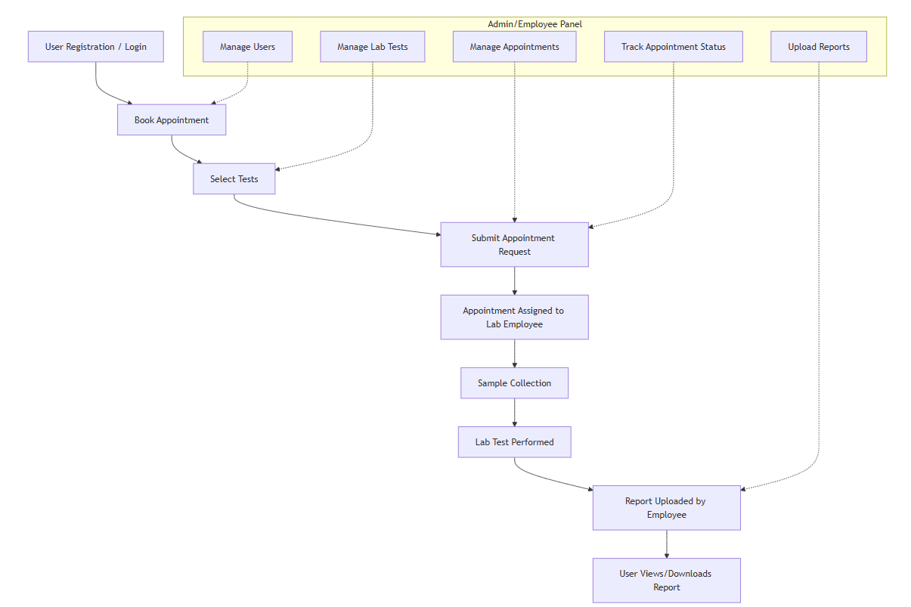

**Figure 1: Flowchart**

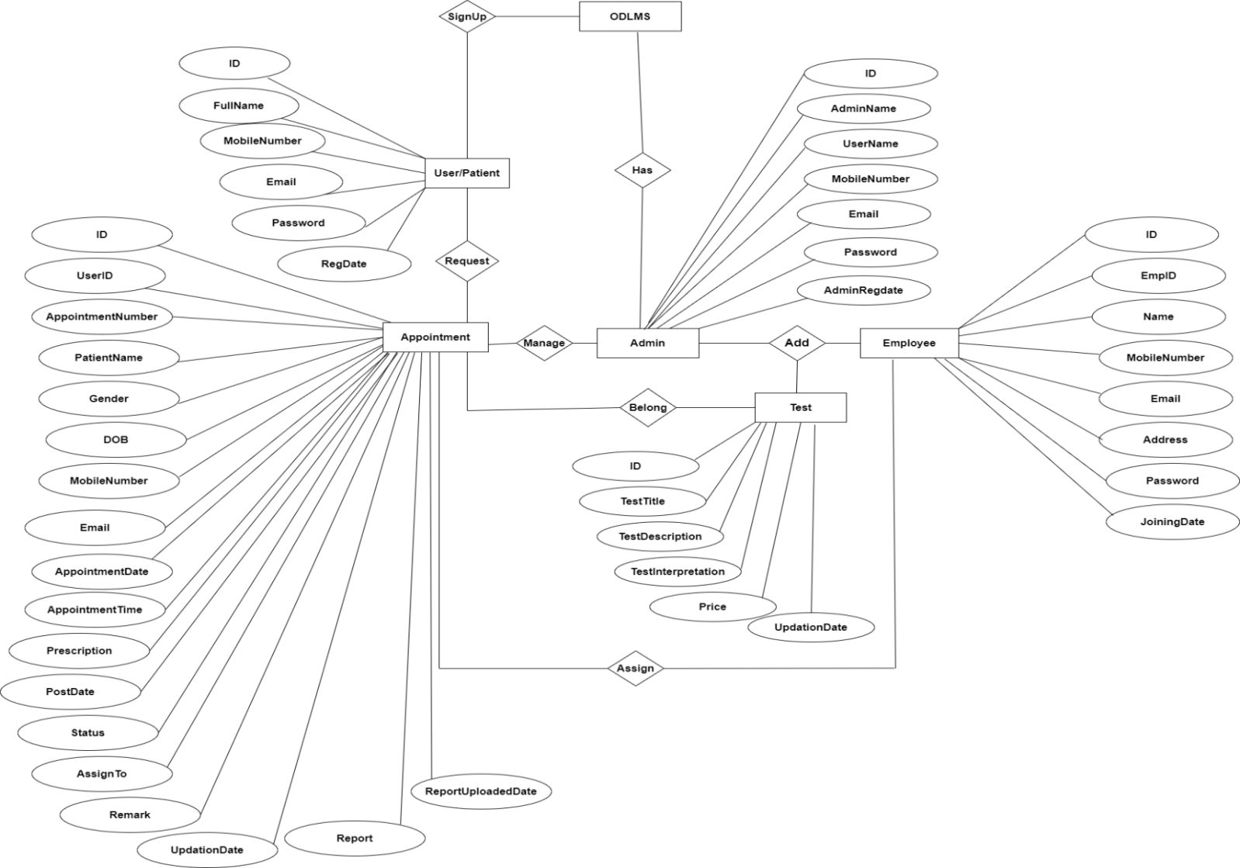**4.2 ER Diagram**

Figure : ER Diagram DMCMS

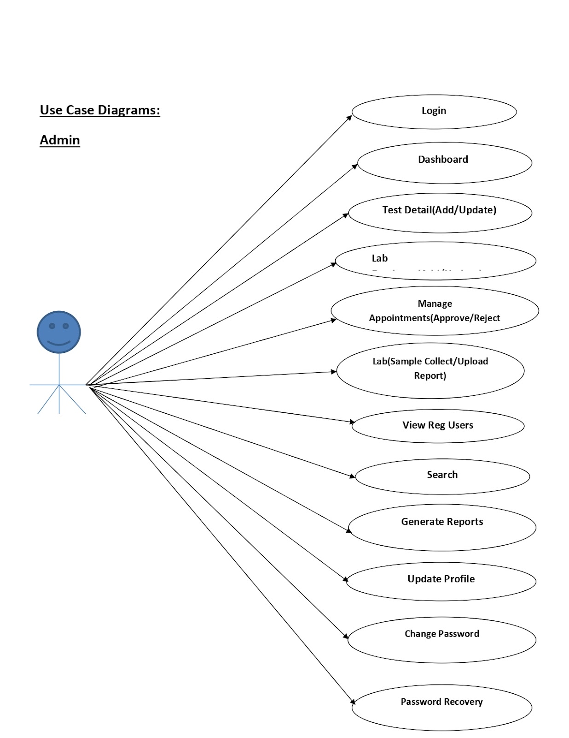

**4.2 Use Case Diagram-Admin**

**Admin**

Figure : Admin’s Use Case Diagram

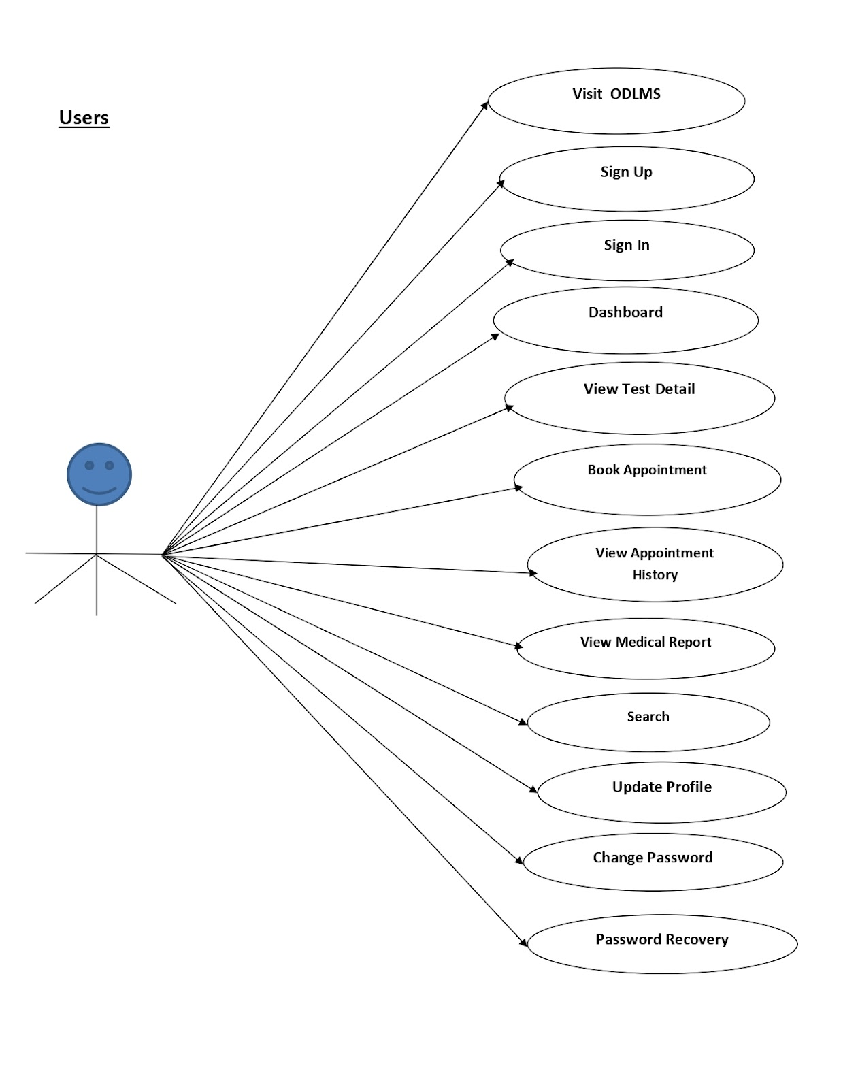**Figure :** Users Use Case Diagram

**User**

**Home**

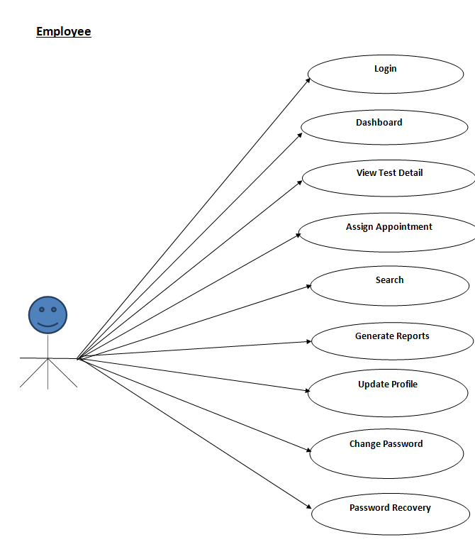

**Employee**

**Figure : Employees Use Case Diagram**

**4.3 UML Class Diagram**

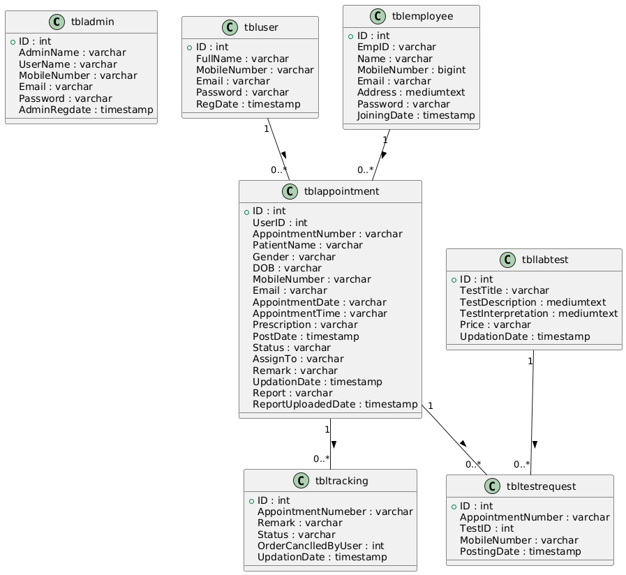

**Figure : UML Class Diagram**

**CHAPTER 5**

**GRAPHICAL USER INTERFACE**

**Home Page**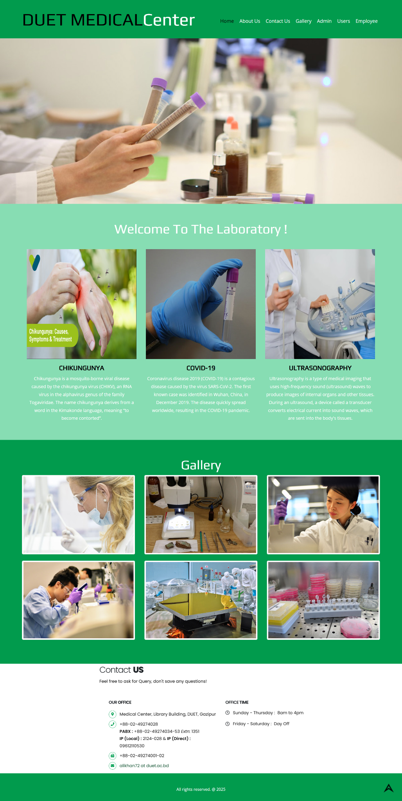

**Admin Login**

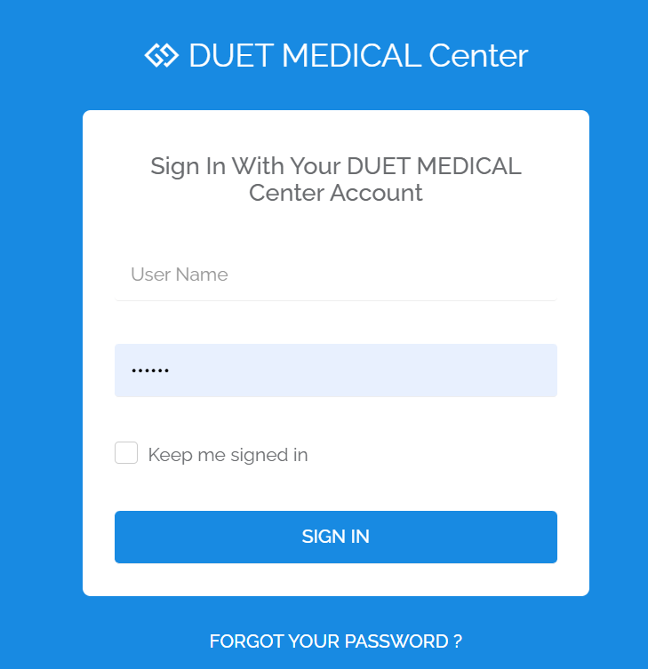

**Dashboard**

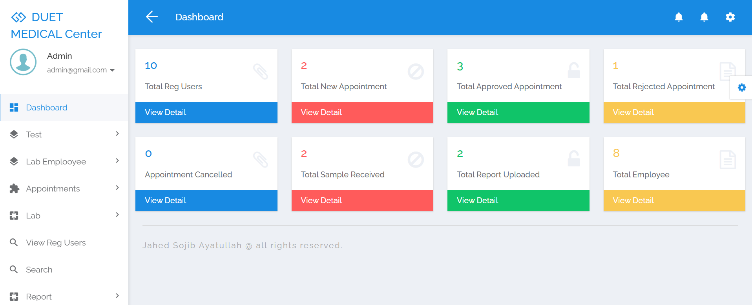

**Manage Test**

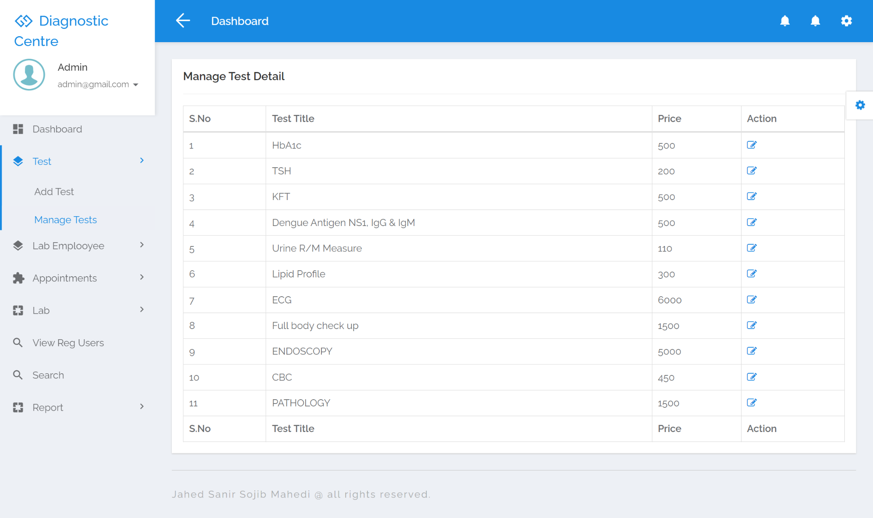

**Add Lab Employee**

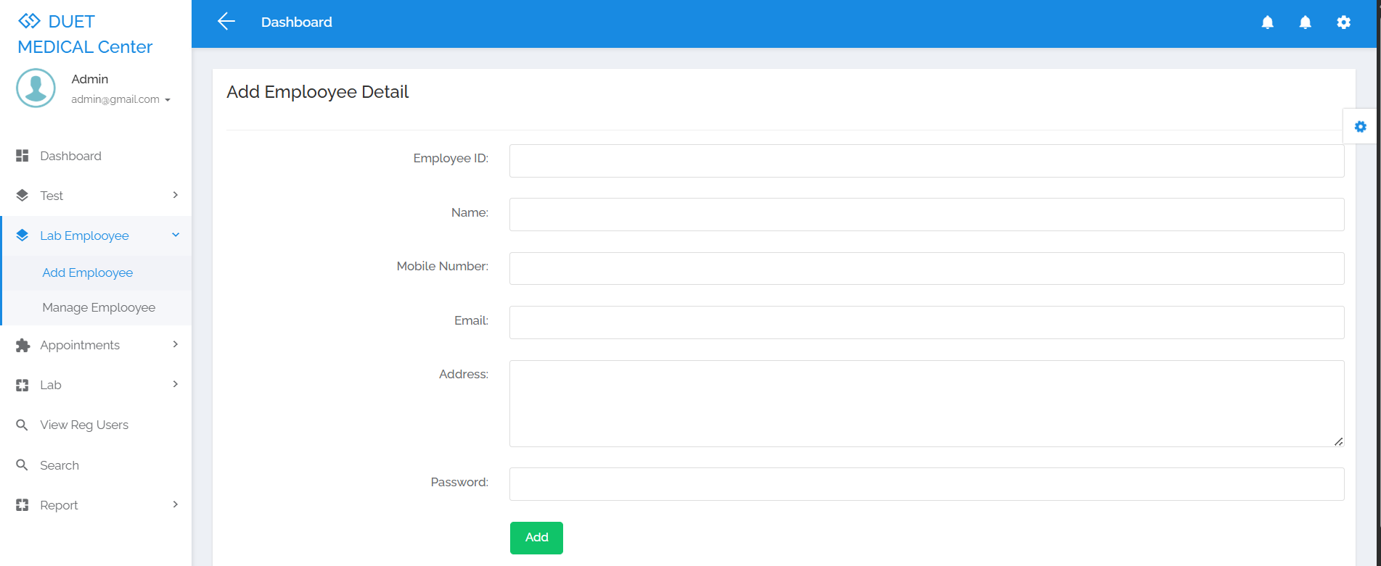

**Appointment Details**

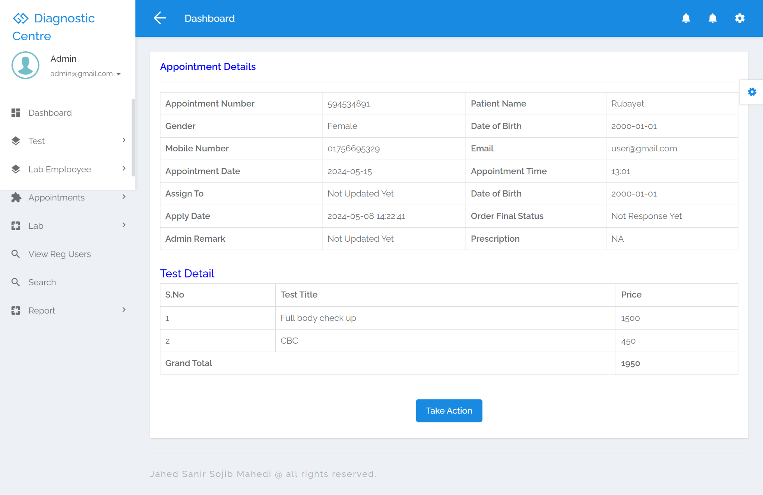

**Sample Received**

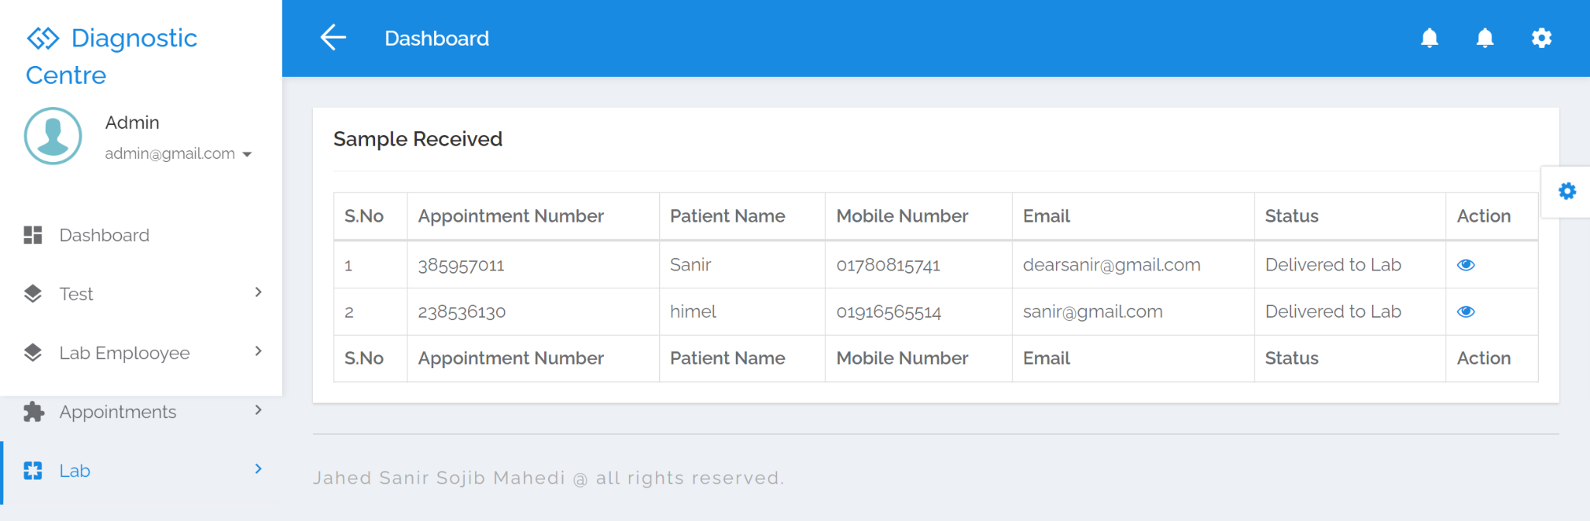

**Search**

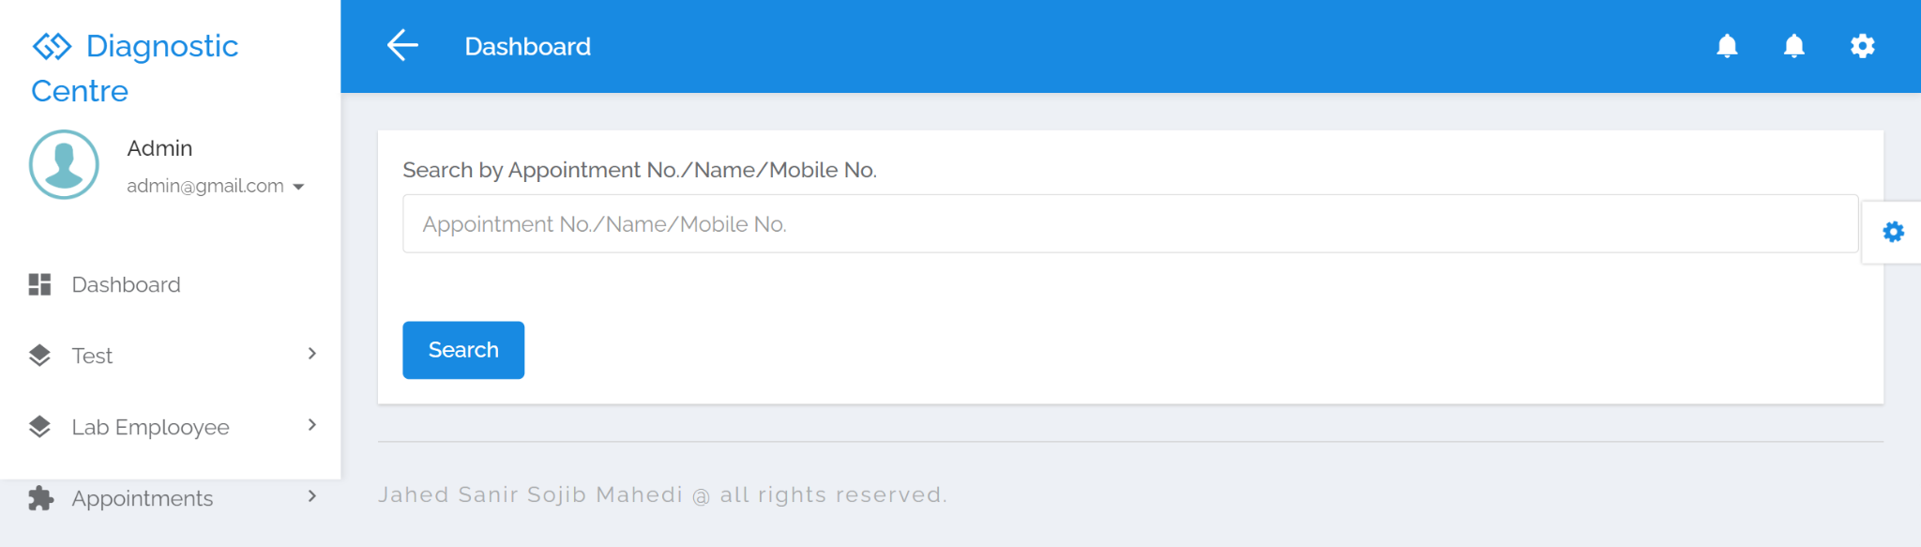

**View Medical Report**

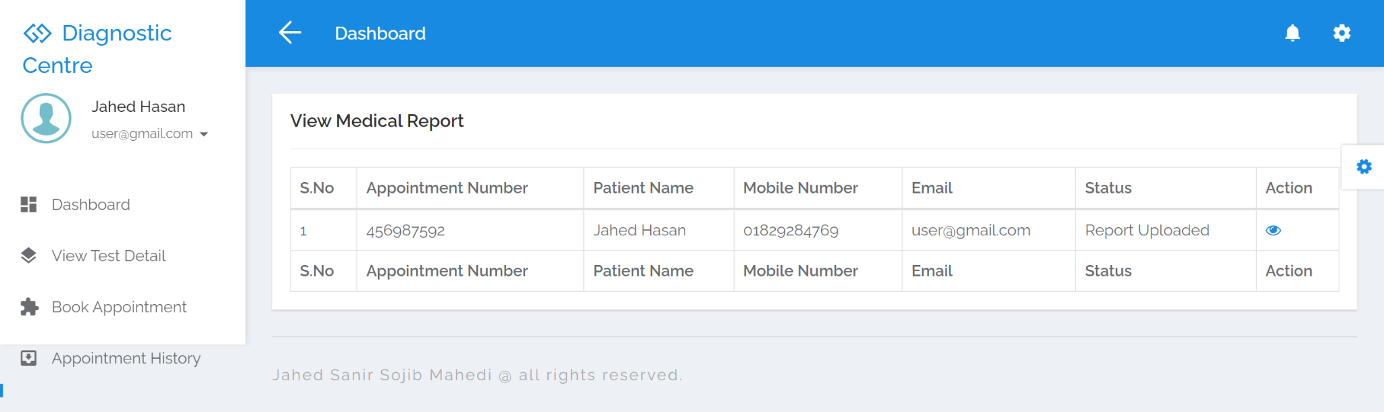

**User View Detail**

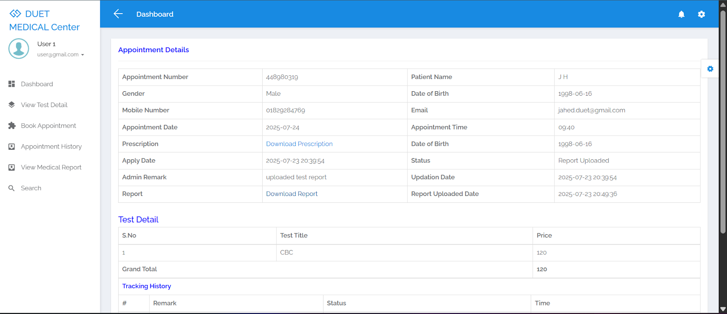

**Chapter 6**

**Testing**

**6.1 Responsiveness Testing**

Mobile View

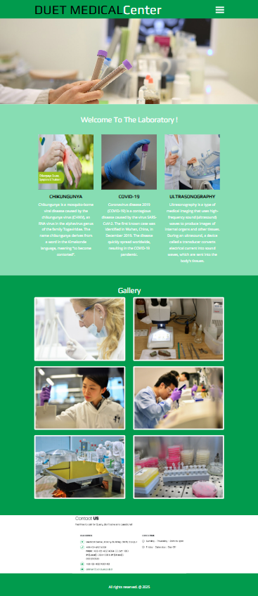

Website responsiveness testing ensures that a website looks and functions correctly across various devices and screen sizes, including desktops, tablets, and smartphones. This process is essential for providing a consistent and user-friendly experience, regardless of the device being used. It involves checking layout adaptability, image and text scaling, navigation functionality, and touch responsiveness. Tools like Chrome DevTools, BrowserStack, and Google’s Mobile-Friendly Test help identify and fix issues such as overlapping elements, small fonts, or broken layouts. Ultimately, responsive design enhances usability, boosts SEO rankings, and increases user engagement.

**6.2 Deadlink Checking**

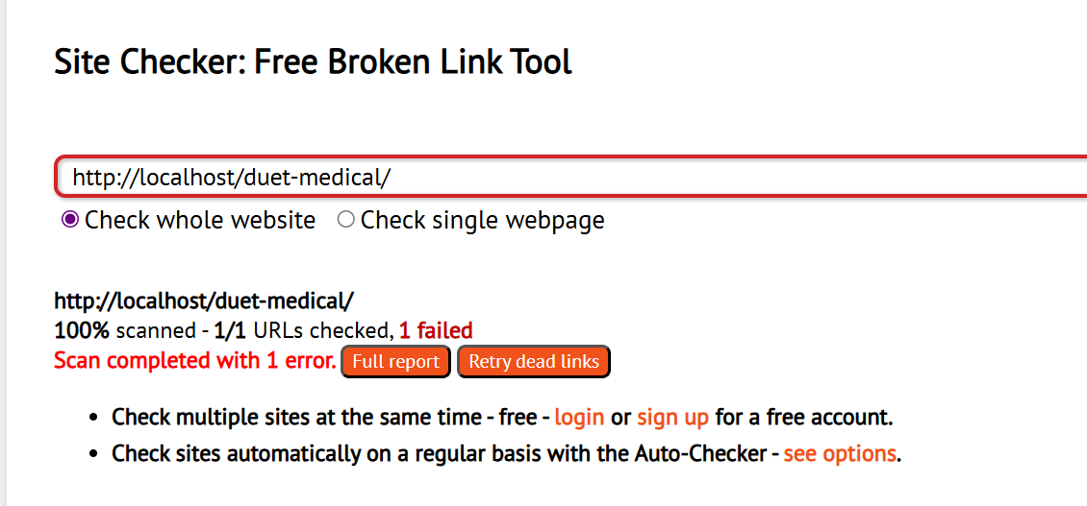A **deadlink checker** scans a website to find broken or non-working links (like 404 errors). These tools help improve user experience and SEO by ensuring all links lead to valid pages. Popular options include Broken Link Checker, Dead Link Checker, and Screaming Frog.

**CHAPTER 7**

**CONCLUSION AND FUTURE SCOPE**

**7.1 Conclusion**

Online Diagnostic Lab system is very much graceful and lively. Patients have to register to the portal by giving their details and then they can take appointment through online with minimal effort. Once appointment is confirm, diagnostic center send the technician to patient address to collect the blood sample. Once test is done and test report is generated patient can downlaod the report by logged in to the portal. This system can be implemented in diagnostic labs and clinics.

• Automation of the entire system improves the productivity.

• It provides a friendly graphical user interface which proves to be better when compared to the existing system.

• It gives appropriate access to the authorized users depending on their permissions.

• It effectively overcomes the delay in communications.  
 • Updating of information becomes so easier.

• System security, data security and reliability are the striking features.

• The System has adequate scope for modification in future if it is necessary.

**7.2 Scope for Further Developments**

1. **Multivendor system :** A multi-vendor diagnostic center system integrates multiple centers into one platform, offering users diverse medical services conveniently. Users can choose centers based on factors like location and specialty. Each center operates independently but benefits from centralized tools for management tasks. This fosters competition and innovation, improving service quality. The system ensures prompt access to healthcare services while empowering centers to operate efficiently.
2. **Integration of Additional Data Sources:** Expanding the scope of data sources beyond diagnostics center to include electronic health records (EHRs), patient preferences, and outcomes data could provide richer insights for personalized recommendations. Integration with wearable devices and health tracking apps could also enable real-time updates and further customization.
3. **Enhanced Personalization:** Implementing advanced machine learning techniques such as deep learning and natural language processing can improve the system's ability to understand and adapt to individual preferences and medical histories, leading to more accurate and relevant recommendations.
4. **Online Payment Method:** Online Payment Methos could be implemented in this project so that transactions can be smoothly.

**7.3 Limitation**

The DUET Medical Centre Management System (DMCMS) project also has several limitations that need to be acknowledged. Firstly, the accuracy and reliability of recommendations heavily rely on the quality of the data available. Incomplete or inaccurate data about diagnostics center can lead to suboptimal recommendations or biased results. Moreover, the system may face challenges in accommodating diverse user preferences and medical needs, particularly in cases where certain diagnostics services are niche or specialized. Additionally, the recommendation system may not account for individual medical histories or conditions, which can significantly influence the choice of diagnostics center. Furthermore, there may be limitations in the scalability of the system, particularly as the number of users and diagnostics center increases, which could impact response times and computational resources. Lastly, the system may not fully address issues of equity and access in healthcare, as it relies on existing infrastructure and may inadvertently reinforce disparities in healthcare access based on factors such as geographic location or socioeconomic status. Despite these limitations, the DMCMS project aims to mitigate these challenges through ongoing refinement and improvement, guided by user feedback and iterative development processes.

**REFERENCES**

[1]ONLINE DIAGNOSTIC LAB MANAGEMENT SYSTEM. by P Deshmukh. Available at: <https://www.irjmets.com/uploadedfiles/paper/issue_6_june_2022/26623/final/fin_irjmets1655965452.pdf>

Hypertext Mark-up Language

[2] W3schools.com. 2021. Introduction to HTML. [online] Available at: <http://www.w3schools.com/html/html_intro.asp>

Introduction with PHP.

[3] W3schools.com. 2021. PHP Introduction. [online] Available at: <https://www.w3schools.com/php/php_intro.asp>

Introduction with CSS

[4] W3schools.com. 2021. CSS Introduction. [online] Available at: <https://www.w3schools.com/css/css_intro.asp>

MySQL, Opensource database.

[5] Dev.mysql.com. 2021. MySQL :: MySQL 5.7 Reference Manual :: 1.2.1 What is MySQL?. [online] Available at: <https://dev.mysql.com/doc/refman/5.7/en/what-is-mysql.html>

Youtube Video Tutorial.

[6] Youtube.com . [online] Available at: <https://www.youtube.com/watch?v=q_16ASAk03U>